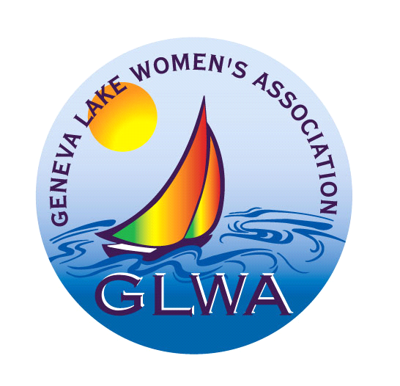
Geneva Lake Women's Association

GLWA SCHOLARSHIP

PURPOSE:

The Geneva Lake Women’s Association (GLWA) established a scholarship program to encourage community service and the development of personal goals in an individual’s life. The scholarship will support and assist a student who has the ability and desire to receive an education beyond high school.

ELIGIBILITY:

- Performed a minimum of 60 hours of community service throughout four years of high school. Hours must be documented. See instructions below.

- Maintained a “B” average throughout high school or better (3.0 on a 4.0 scale or equivalent).

- Accepted at a college, university, technical school, or trade school for Fall term following graduation.

- A citizen or legal resident of the United States and resident of Walworth County
or Graduating from a public or private high school located in Walworth County.

- Female

INSTRUCTIONS:

Note: If any information requested below is not included, applicant’s submittal will be discarded and not be considered for scholarship.

- Provide typed letter of application with all information requested, in order.

- Provide a letter or essay to define biographical sketch, personal goals/mission statement, community service involvement, area of study for post-secondary education, name of college attending in Fall term, high school activities, extracurricular activities, interests or hobbies, extenuating circumstances (financial need, handicap, etc.). Please limit your essay to maximum of two typed pages (double spaced). All information will be kept confidential.

- Provide documentation of 60 hours of community service performed during your high school career. This may be a letter(s) from activity’s contact person or can be a list form for each activity compiled by you. Information should include all events, activities and/or civic involvement with dates (month and/or year) and number of hours served for each. Describe tasks performed, name and phone number of contact person organizing the community event (for verification). Each activity must be signed by each contact person for each event. “Community Service” credit forms (handwritten, multiple, redundant sheet forms) used by high school requirements will not be accepted as documentation of service hours (due to costs to reproduce for review).

- Provide one character reference letter. This should be from a teacher, coach, pastor, youth minister or employer, etc.

- Provide a current transcript from the principal or high school counselor from school now attending that addresses scholastic eligibility (“B” average, 3.0 on a 4.0 scale or equivalent, or better for entire high school career).

- Send scholarship submittal with all enclosures requested to:

Scholarship Chair
c/o Geneva Lake Women’s Association
PO Box 671
Lake Geneva WI 53147

- Submittals must be postmarked no later than the Second Monday in April. Submittals received past this date will be discarded and not considered for scholarship.

AWARDING OF GLWA EDUCATION SCHOLARSHIP

- The scholarship committee will review all applications and select the award recipient without regard to ethnicity, religion, or disability.

- The award recipient will be notified of their selection at the school’s award ceremony.

- The scholarship of $500 (five hundred dollars) for up to four consecutive years of post-secondary education will be paid directly to the recipient’s school to assist with the tuition and books. The recipient will only be eligible for $500 for each year in attendance limited to four consecutive years (maximum not to exceed $2000). If recipient is attending a program that is less than four years, she is only eligible to receive $500 for each year in attendance (up to four years) and will not receive the remainder or equivalent of a four-year attendance amount.

- Each year’s award of $500 will be made after the GLWA scholarship committee receives a grade transcript of the first term grades for each of the four consecutive years of attendance at the post-secondary school. The transcript will verify that the recipient has maintained a 2.5 grade point average (on a 4.0 scale) with full time student status. Submit with the transcripts the student identification number and address of the tuition office of the school you are attending for direct payment. (GLWA contact person’s address will be provided at time of scholarship award.)

If you have any questions regarding this scholarship application, contact Cathy Stoodley at (262) 215-0002 or email at catherinestoodley@yahoo.com

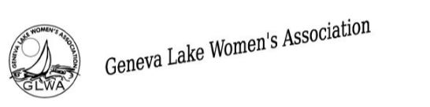

LETTER OF APPLICATION REQUIREMENTS

Please provide the following information typed, in a neat and clear format, in order, the answers to the following questions:

- Name

- Address

- Phone number and email address (one checked regularly by student or parent/guardian)

- Last four digits of Social Security (full social security number or college student ID will be needed if scholarship is awarded)

- High School Currently Attending

- List Community Services performed during your high school career with dates and hours completed for each (60 hour minimum required). In addition to this summary list, attach documentation of these 60 hours of community service listed with all the information requested and in the form, described in the Instructions on page 2 above.

- List extracurricular activities you participated in during your high school career. (i.e., athletics, clubs, and/or organizations).

- List any awards or recognitions you have received while attending high school.

- If you worked during high school, list place of employment with number of hours per week.

- Sign and date your letter of application.

Important Note:

Be sure to include all attachments requested in the Instructions on page 2 or applicant’s submittal will be discarded and not be considered for scholarship.

